The TOP LEFT BY DEFAULT

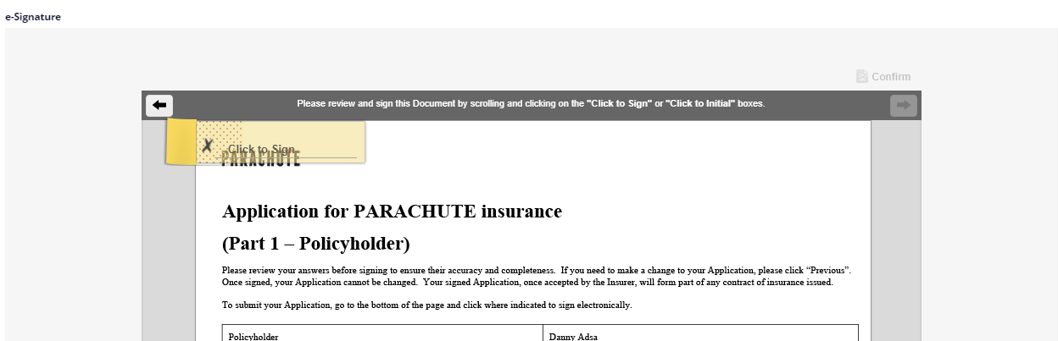

The BOTTOM LEFT WHICH WE HAVE CONFIGURED AS PER OUR REQUIREMENT BY USING THE BELOW TAG
{{esl:Signer1:Signature}}

