Esign in Mobile view

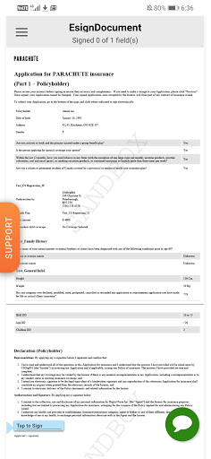

When the tap sign is clicked ,it is changing to accepted and then the pop-up appears .In the pop-up even when cancel is clicked it is showing accepted. ”Please complete the signature” message is not shown in the document to complete the signature when cancel is clicked in pop-up

Expected Result:
It should show ”Please complete the signature” message in the document .When cancel is clicked in the pop-up.

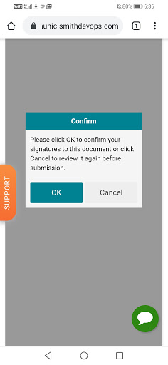

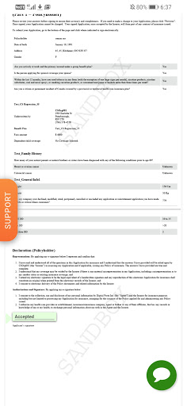

E-sign for spouse is shown as below:

