The transaction was already sent out, signed, attachment uploaded and then rejected.
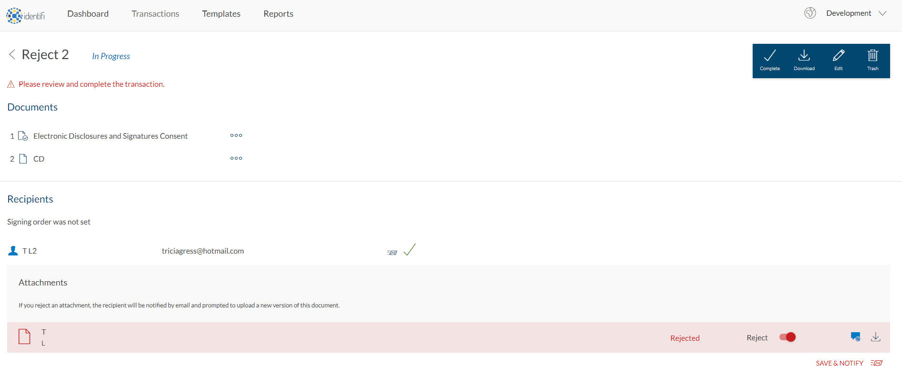
Then the sender clicks the Edit Button so the transaction is now in the Draft Status

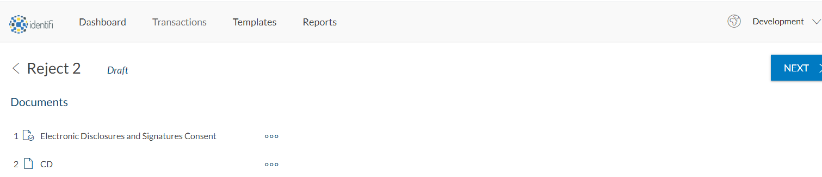
Within our application, the Sender clicks the next button to navigate them to the iframed designer. When that happens in our application we first save the data in the package. So at this point we are just trying to update the signer information in case anything has changed.
We call UpdateSigner and pass in the edited Signer object
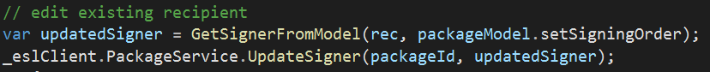

Here is where we get an error from OneSpan

