First, I use /authenticators service to list authenticator information:
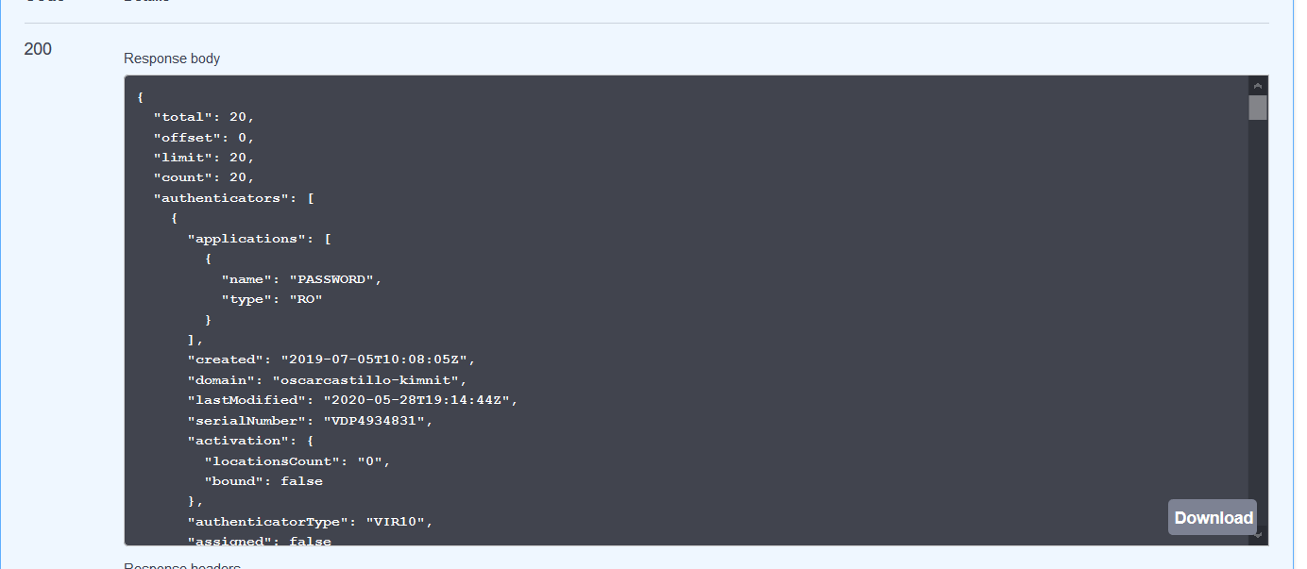

Second I delete all users used previously and left only one user, that i will use on next tests.
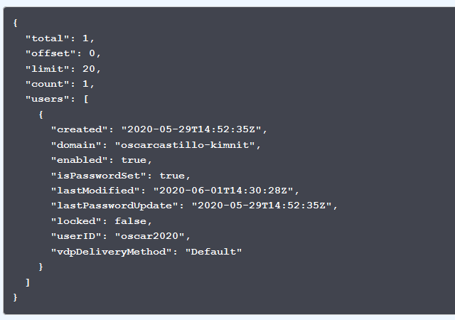

To start the test I use /register Service to register user oscar2020

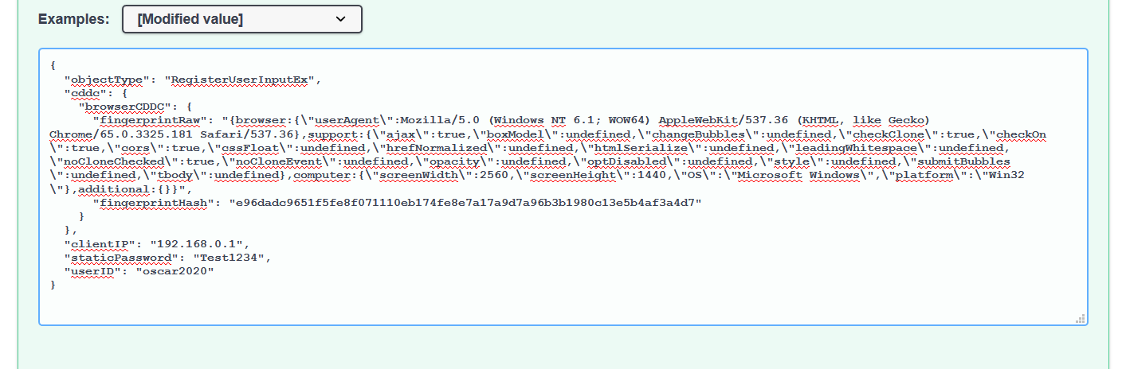

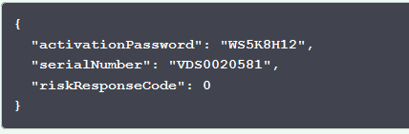

Then i Activate the user using the Orquestator Sample app.

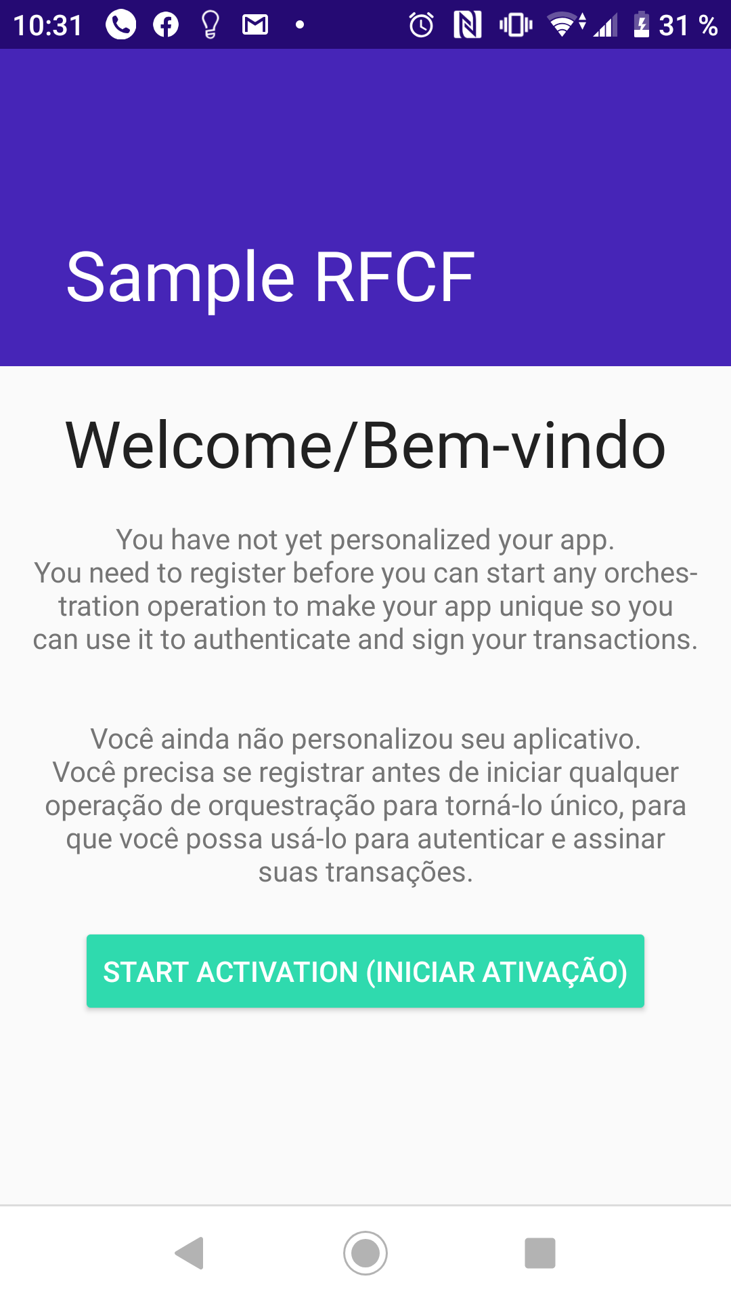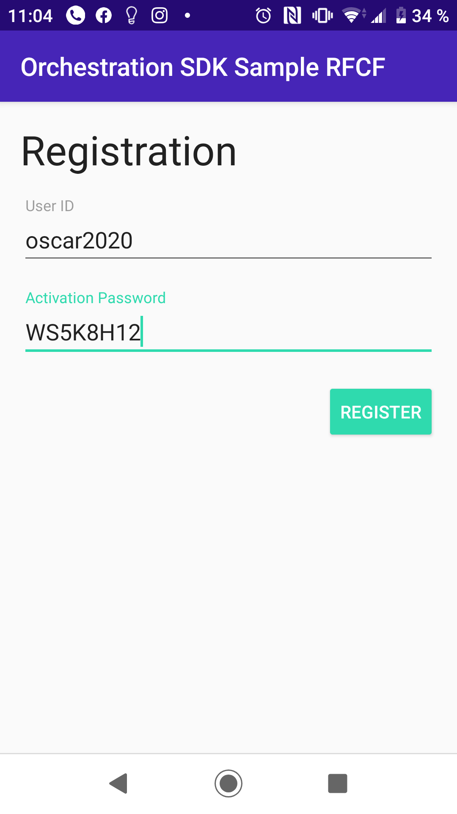
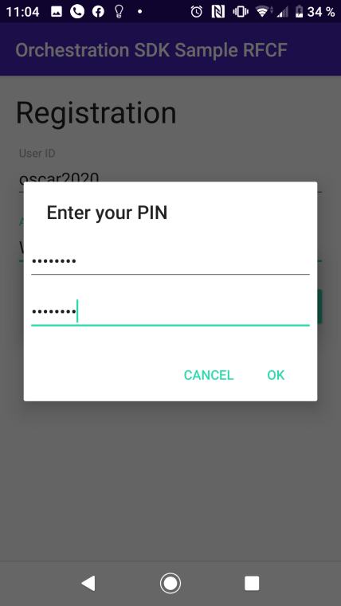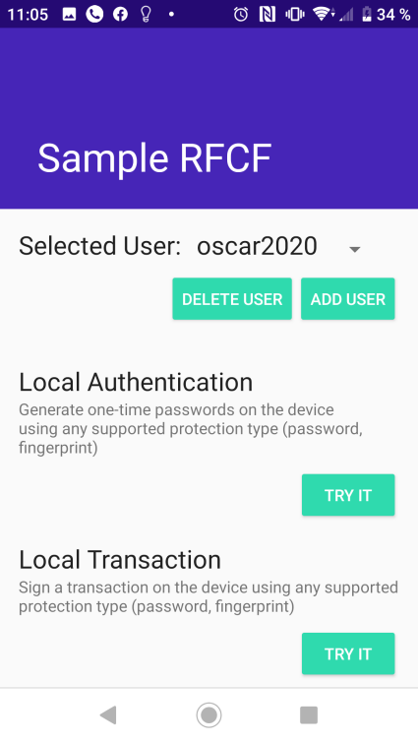

Now I consume again /users service
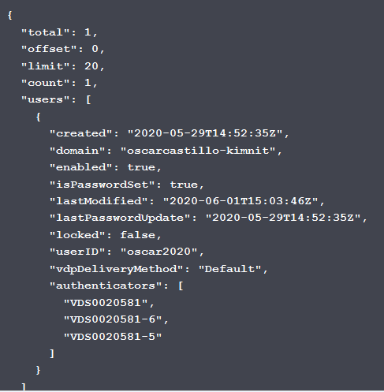

Now i use /register Service to register another User oscar2021
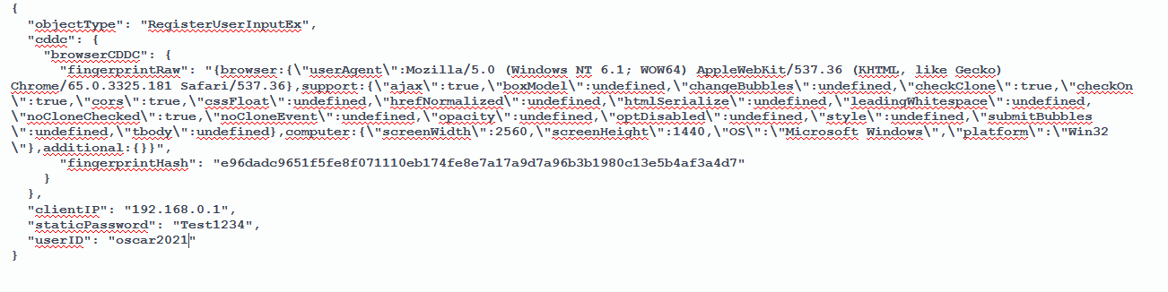

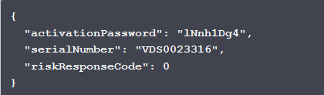

I register this user on the Orquestator Sample App

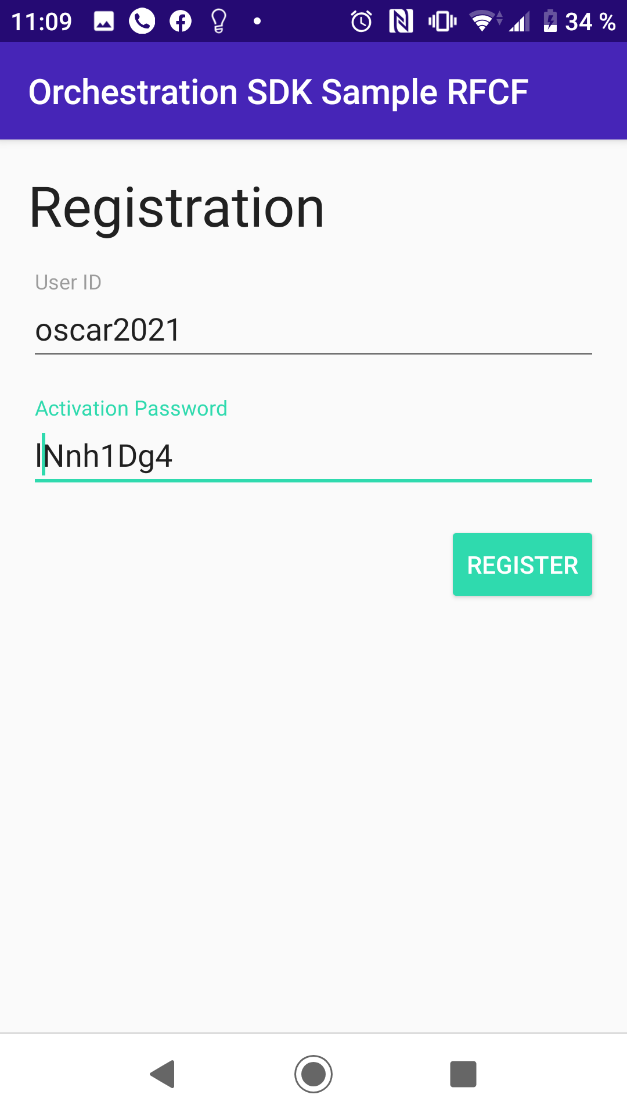

This time i use 1357 as PIN

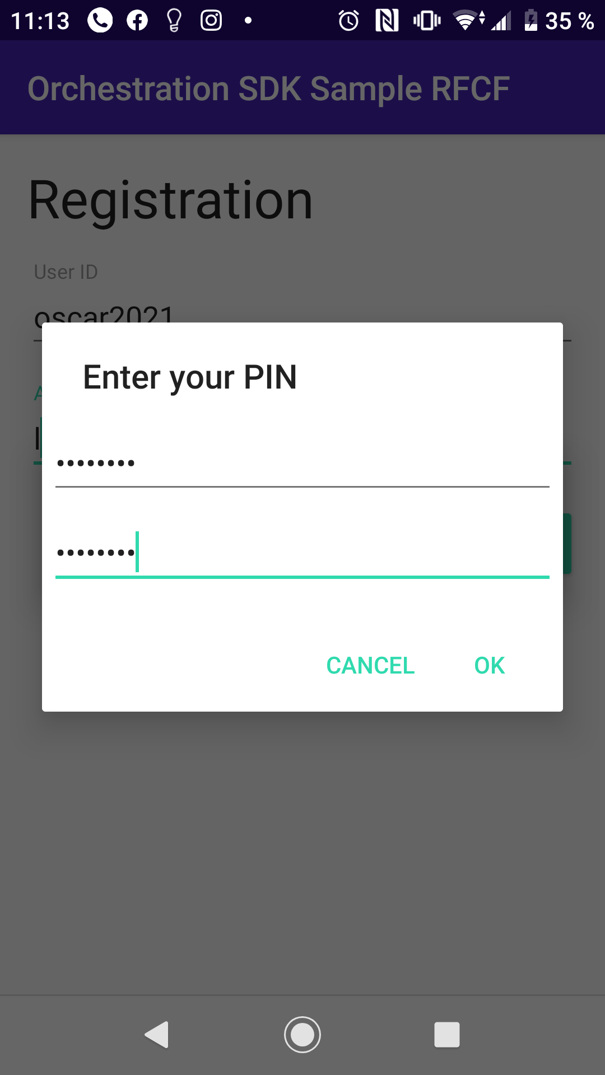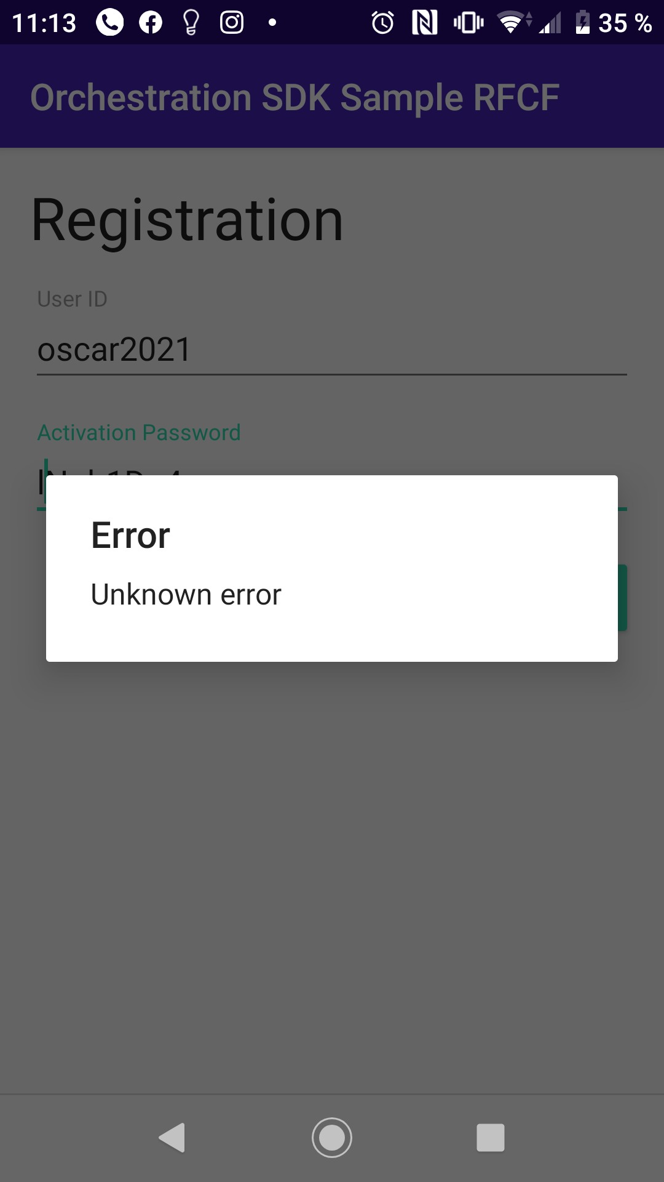
The error throws on LogCat Console
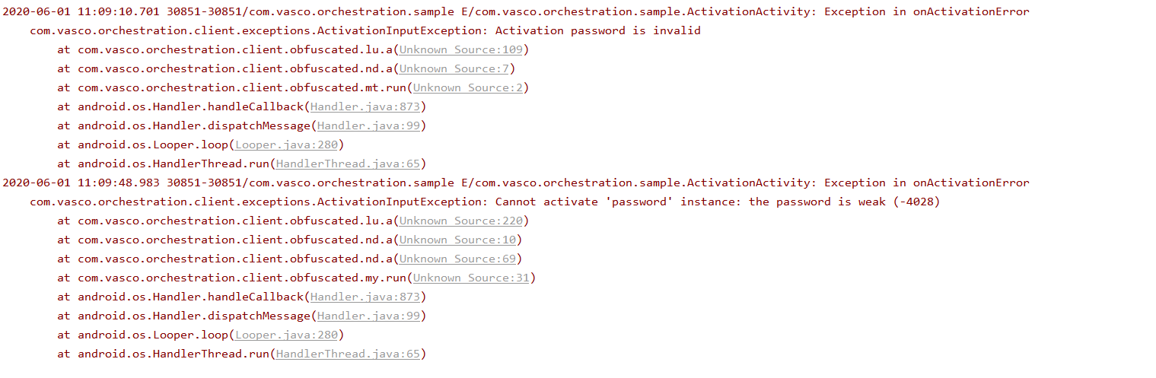
Now I try to use PIN 13571357 (used also with the user oscar2020)

Error is shown

Now I show the userList
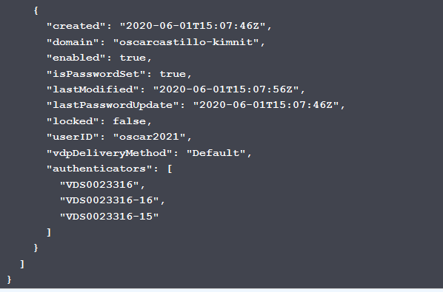

I unnassign authenticator VDS0023316
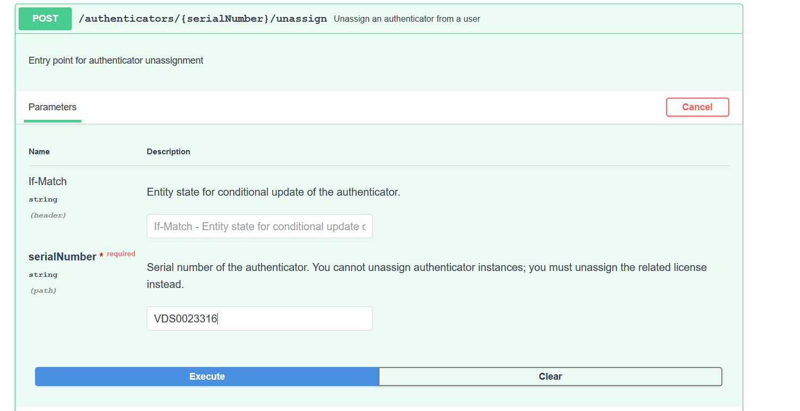

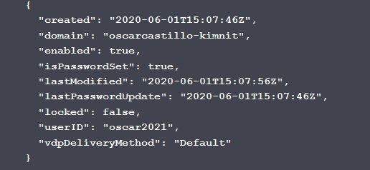

Now I use service /register
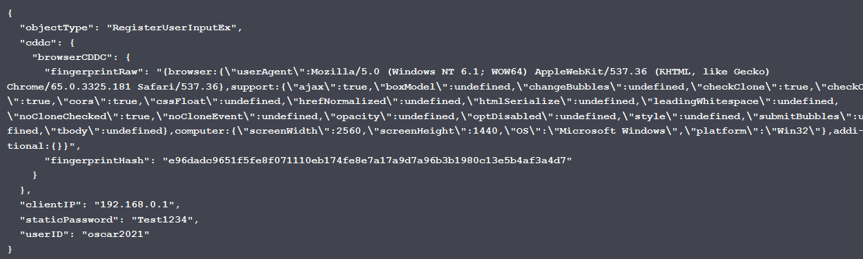

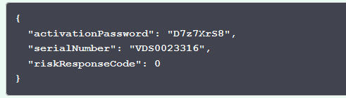

I activate Authenticator on Orquestator Sample App
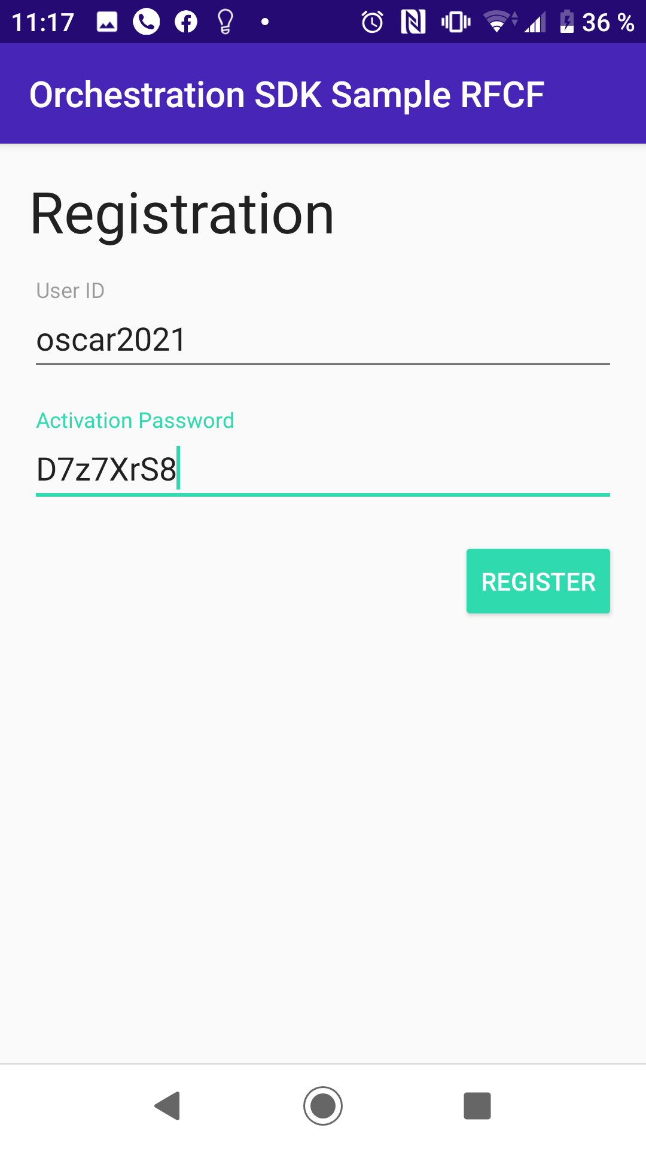

I use PIN 13571357

