- We create a new instance of the EslClient

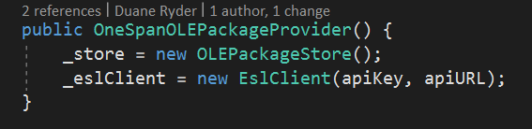

- We create a OneSpan Signer object and set all of the properties using our model

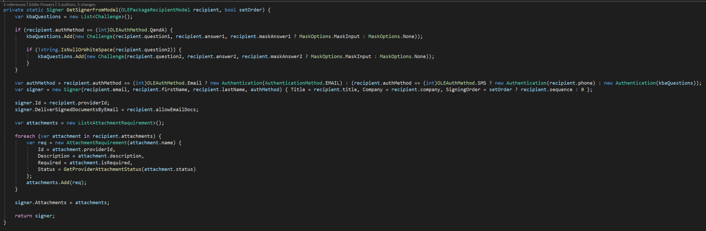
- We call UpdateSigner and pass in the edited Signer object

